RESOLUTION NO.__________

RE: CERTIFICATE OF APPROPRIATENESS UNDER THE
PROVISIONS OF THE ACT OF THE PENNSYLVANIA
LEGISLATURE 1961, JUNE 13, P.L. 282 (53
SECTION 8004) AND BETHLEHEM ORDINANCE NO.
3952 AS AMENDED.

WHEREAS, it is proposed replace windows, downspouts and gutters; also, to restore the siding, trim and woodwork to at 321 W. Fourth St.

NOW, THEREFORE, BE IT RESOLVED by the Council of the City of Bethlehem that a Certificate of Appropriateness is hereby granted for the work.

Sponsored by: (s)

(s)

ADOPTED BY COUNCIL THIS DAY OF

(s)
President of Council

ATTEST:

(s)
City Clerk

HISTORIC CONSERVATION COMMISSION

CASE # 624– It is proposed replace windows, downspouts and gutters; also, to restore the siding, trim and woodwork to at 321 W. Fourth St.
OWNER/APPLICANT: Episcopal Ministries of D.B., Inc/ Paul Thiessen, JPT Contracting

The Commission upon motion by Mr. cornish seconded by Mr. Lousch adopted the proposal that City Council issue a Certificate of Appropriateness for the proposed work described herein:

- The proposal to replace windows, downspouts and gutters; also, to restore the siding, trim and woodwork at 321 W. Fourth St. was represented by Paul Thiessen, JPT Contracting. The following were approved:

- Gutter & Downspouts
  - Installation of 5” white aluminum half-round gutter on the front of the property
  - The downspout on the left of the front façade will remain in the same location.

- Windows & Sills:
- The wood window sashes will be reinstalled and repaired.
- Triple track aluminum storm windows will be installed. The color must be reviewed by the Historic Officer.
- All rotted wood trim and sills will be repaired with Abitron or Advanced Repair Tech (or equivalent). The sills will only be replaced where absolutely necessary with similar hardwood and painted.
- The wood and wood shingles on the bay window will be scraped and painted.

- The non-functional chimneys on the east and north will be removed.
- The front aluminum awning will be removed.
- Siding & Masonry:
- The existing Brickote will be patched to match the existing using SpecMix Fiber Base coat and Federal White Portland Cement mixed at a 3:1 ration of Jersey Sand to Portland
- The cedar siding will be scraped, primed and painted.

- The Historic Officer will be available to assist with a new color scheme for the building if desired.

- The motion to approve the proposal was unanimously approved.

CU: cu
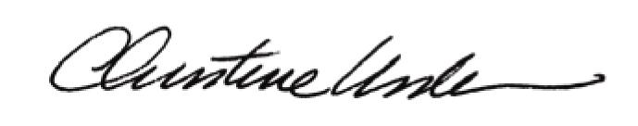

By:

Date of Meeting: August 21, 2017 Title: Historic Officer

